# **Implementation of Google Forms**

**Introduction**

Google Forms is a versatile tool provided by Google for creating surveys, quizzes, and forms. It allows users to easily design and distribute custom forms to gather information or feedback from respondents.

**Working with google forms**

1. Go to the official website of google forms then



1. Click on the Go to forms button.

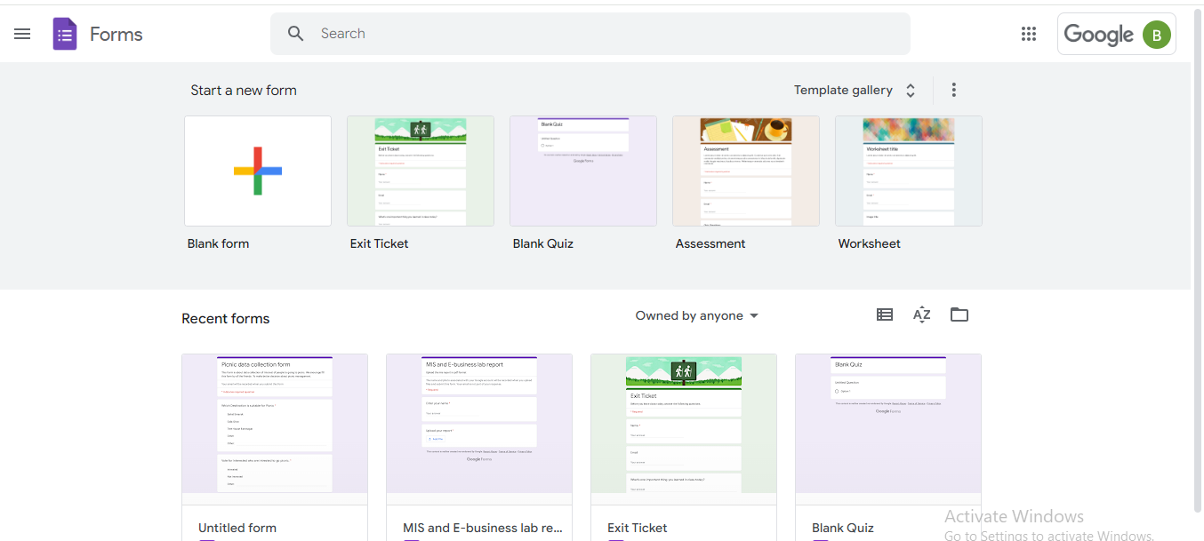

1. And Select the suitable template for you for your data collection or you can create also a blank form and create it.
2. Then the form builder is open . Set a Form Title and Form description according to your data collection model.
3. Then Create a first question and select the response type.

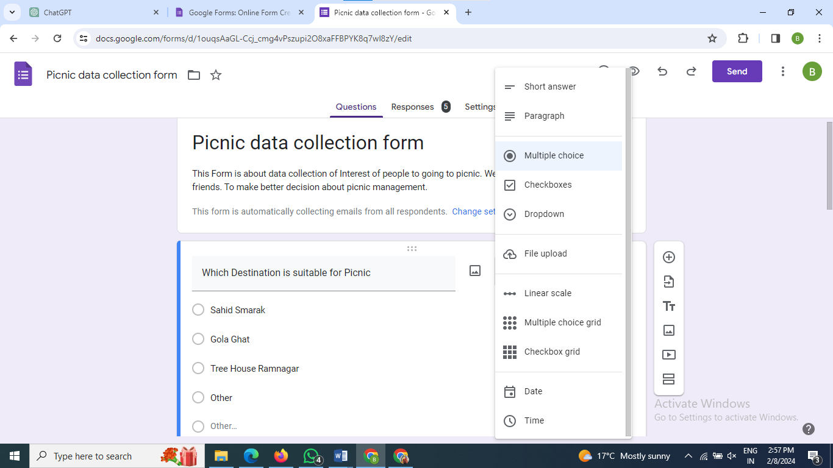

1. Add the set of questions and other similar responses .
2. After that click on the send button in top right.Then Send Form dialog opens and copy the share link. And share link to other friends.

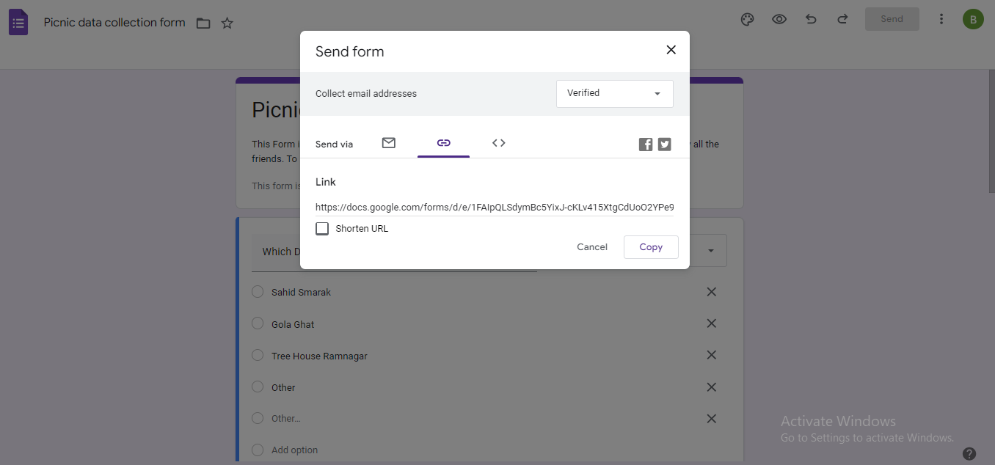

**Responding the Form data**

1. Click on the form share link send by the your friend. Then response the following set of questions and click on submit button.

